CareerGUIDE — Verification Report v4 (consolidated)
Master report — consolidates v1 (bug register), v2 (flow & data audit), v3 (code root cause) and v4 (exhaustive checklist + new findings).
Application: brainstyle.netlify.app + source repo github.com/Punyamittal/careerGuide · Date: 7 June 2026
1. Summary
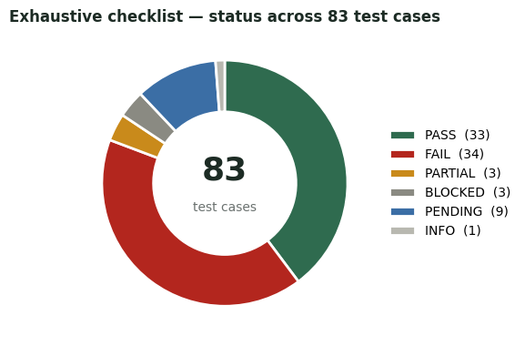

- No assessment flow completes. career_g11 is blocked at question 1; the three grade-school flows start and score but break mid-way. Both new back-ends (clarification & Negotiation V2) are deployed-but-down.
- Root cause is data/deploy, not deep logic: a stale database, uncommitted data files, and position-based question binding. The engine, scoring, games, internships, Life Journey, reports and auth all work.
- Single highest-leverage fix: re-seed the live DB and commit the psychometric data files — that unblocks the assessment, MBS modules, reports and the clarification phase together.
2. Consolidated issue register (all versions)
Every distinct issue found across v1–v4, ranked by severity. Items you asked me to set aside are listed at the bottom, marked EXCLUDED, for completeness.
Sev | Issue | Status | First seen | Note
CRITICAL | Assessment cannot be completed (any flow) | Open | v1 | career_g11 → 503 at Q1 (MOT_18–28); early/middle/stream break at RIA_R_03
HIGH | MBS behavioural modules render an empty question | Open | v1 | 11 modules load; no prompt or options
HIGH | Clarification engine (Phase 7.5) returns 502 | Open | v4 | /api/v1/v6 — MongoDB backend not available
HIGH | Negotiation V2 /start times out (504) | Open | v4 | hangs; also not linked in the UI
HIGH | Live DB stale vs repo seed | Open | v3 | 17 of 28 motivation items seeded
HIGH | Psychometric data files not committed to repo | Open | v3 | seed + backend depend on uncommitted JSON; silent fallback
HIGH | Only 4 of 6 user flows wired | Open | v2 | 5th & ecosystem-2026 absent from ASSESSMENT_PLANS
HIGH | Internal backend error shown to end users | Open | v1 | “node scripts/seed.mjs” on the assessment page
MEDIUM | AI coach never replies (fallback only) | Open | v1 | POST /ai/chat → provider:"fallback"
MEDIUM | 8 game titles reuse only 4 engines | Open | v1 | Pattern=Maze · Focus=Memory · Rhythm=Reaction · Stability=Balance
MEDIUM | Career-match % are placeholder & inconsistent | Open | v1 | 88/81/97% shown with no assessment
MEDIUM | Profile stats out of sync with activity | Open | v1 | XP/sessions stay 0 after a played game
MEDIUM | Logged-in users routed to /register at “/” | Open | v1 | should land on the dashboard
MEDIUM | Positional question-binding is fragile | Open | v3 | riasec[idx]/motivation[i] — drift → missing_question_code
MEDIUM | .ts routers imported into .js; duplicate /v6 mount | Open | v4 | deploy risk in routes/index.js
MEDIUM | Social-desirability scoring not implemented | Open | v2 | only 6 reverse-scored items present
LOW | Validation error placed far from its field | Open | v1 | intake age error renders at the bottom
LOW | Intake answers don’t persist on revisit | Open | v1 | resets to defaults
LOW | Page heading always reads “Overview” | Open | v1 | does not reflect the active tab
LOW | Career-sim voice is fallback (no TTS) | Open | v1
LOW | Search box / category chips / “See all” are cosmetic | Open | v2 | no filtering or effect
MINOR | 404 page is the bare Next.js default | Minor | v4 | works, but unstyled
EXCLUDED | Password policy not enforced | Excluded | v1 | weak 6-char password accepted (set aside at your request)
EXCLUDED | Admin console reachable by students | Excluded | v1 | /admin renders for student role (set aside at your request)
EXCLUDED | Registration can hang on “Creating…” | Excluded | v1 | intermittent, no timeout (set aside at your request)

3. Specification vs. implementation scorecard
Feature-doc claim | Found on the live site | Status
Assessment tracks: 4 | 4 wired (3 start, 1 blocked) | PARTIAL
Playable behavioural modules: 11 | 11 listed; render empty | FAIL
MBS modules catalogued: 39 | 39 in the catalog API | PASS
IQ games: 4 | 4 present (Pattern Logic = Maze) | PARTIAL
Physiology games: 4 | 4 present (Rhythm=Reaction, Stability=Balance) | PARTIAL
Virtual internships: 10 | 10 present, render scenarios | PASS
Career profiles: 6 | only 2 surfaced in student UI | PARTIAL
AI layer: Grok / OpenAI | coach returns provider:"fallback" | FAIL
6 user flows (incl. ecosystem-2026) | only 4 wired; 6th archive-only | FAIL
Bias / social-desirability | reverse-scored items only | PARTIAL

4. Root cause (traced in the repo)
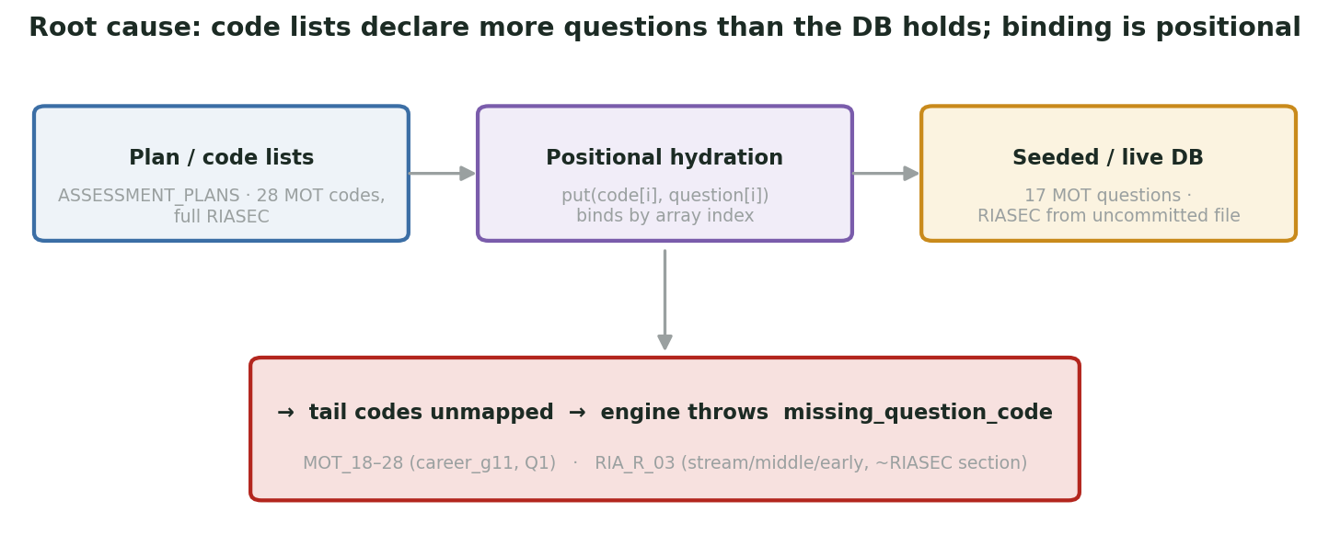
Figure 1 — both blockers share one mechanism: code lists declare more questions than the DB holds, and binding is positional.
The adaptive engine (backend/src/services/adaptive.service.js) throws the exact error seen on screen the moment a planned code has no question:
adaptive.service.js · findAdaptiveProgress()
const q = questionsByCode[cur];
if (!q) return { done:false, error:"missing_question_code", missingCode: cur };

- career_g11 (MOT_18–28): MOTIVATION_CODES lists 28 and the plan uses all 28; the repo seed defines all 28 — but the live DB has only 17. The DB is stale. Re-run node scripts/seed.mjs.
- RIA_R_03 (early/middle/stream): RIASEC items bind by array index, and frontend/data/psychometric-v2-riasec.json is not committed (only a SQL migration references RIASEC). The backend falls back to a 12-code list that omits RIA_R_03, so a present RIA_R_03 row isn’t bound. Commit the data files, re-seed, and bind by external_code.
- Only 4 flows: ASSESSMENT_KEYS = [career_g11, stream_g910, middle_g8, early_g5]; the six MBS_QBank_User_*.json banks (incl. the 6th, “ecosystem 2026”) live only in backend/exports/archive/.
5. Completion attempt & flow coverage
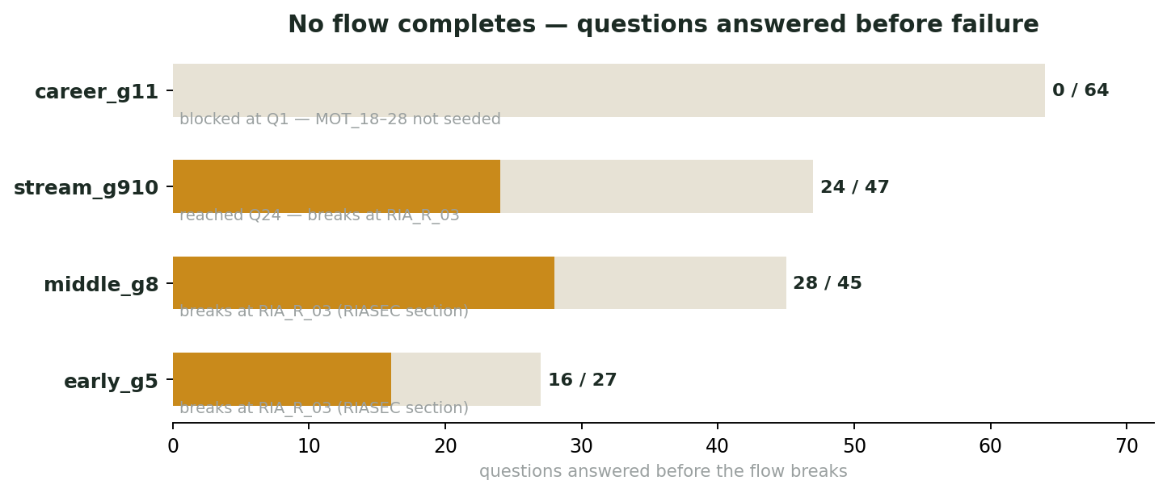
Figure 2 — how far each flow gets before it breaks (driven via the app’s own answer APIs; scoring works until the break).
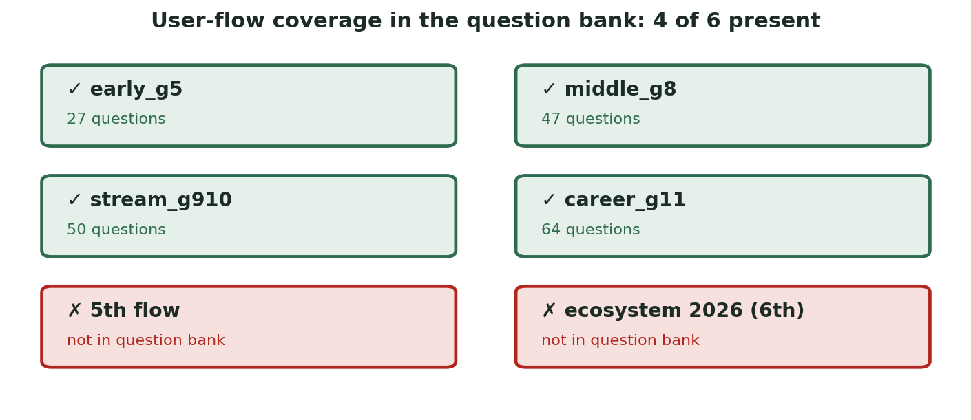
Figure 3 — user-flow coverage in the question bank: 4 of 6 present.
6. Exhaustive test checklist (83 cases)
Status key: PASS works · FAIL bug · PARTIAL works with caveats · BLOCKED gated by another bug · PENDING not yet run · INFO note.
# | Test case | Status | Note
A · Authentication & session (password / admin items excluded at your request)
A1 | Register a new account | PASS | works; can be slow
A2 | Login with valid / invalid credentials | PASS | valid → dashboard; invalid → clear error
A3 | Logout | PASS
A4 | Session persists across reload / navigation | PASS
A5 | Registration can hang on “Creating…” | FAIL | intermittent, no timeout/feedback
B · Onboarding & intake
B1 | Intake form loads (per flow) | PASS
B2 | Age validation (8–80) + required fields | PASS
B3 | Validation error shown near the field | FAIL | shown at form bottom, no scroll-to-field
B4 | Intake answers persist on revisit | FAIL | resets to defaults
B5 | “Save profile & start questions” | PARTIAL | works on unblocked flows; fails on career_g11
B6 | “Discard session” button | PENDING
C · Assessment engine & flows
C1 | career_g11 starts | FAIL | 503 — MOT_18–28 not seeded
C2 | stream_g910 / middle_g8 / early_g5 serve questions | PASS | 27 / 45 / 47 items, valid options
C3 | Adaptive next-question | PASS | works on unblocked flows
C4 | Answer recording — MCQ (selectedOptionKey) | PASS | PATCH …/responses
C5 | Answer recording — Likert (likertValue) | PASS
C6 | Writing free-text answer | PENDING | flow breaks before reaching it
C7 | Complete any flow end-to-end | FAIL | all break at RIA_R_03 (missing_question_code)
C8 | Scoring accrues during the run | PASS | rewardPoints climbed to 187
C9 | Final scoring + report generation | BLOCKED | cannot complete a flow
C10 | 6 user flows exist | FAIL | only 4 in ASSESSMENT_PLANS; 5th & ecosystem-2026 absent
C11 | assessmentKey validated at attempt creation | PASS | enum of the 4 flows
D · Question bank & data integrity
D1 | 64-question bank loads | PASS
D2 | Options valid (MCQ / Likert / free-text) | PASS
D3 | MOT_01–17 present | PASS
D4 | MOT_18–28 present in live DB | FAIL | missing — DB stale vs repo seed
D5 | RIA_R_03 bindable by the engine | FAIL | row exists but positional hydration drops it
D6 | Social-desirability scoring | FAIL | not implemented (only 6 reverse-scored items)
E · MBS behavioural modules
E1 | 11 modules listed (M1–M12) · 39 catalogued | PASS
E2 | Module launches | PASS
E3 | Module renders a real question | FAIL | empty question box
F · Clarification engine (Phase 7.5 / U1–U17) [NEW THIS ROUND]
F1 | Routes mounted (/api/v1/v6/…clarify…) | PASS | mounted, not 404
F2 | Clarify endpoints respond | FAIL | 502 “unknown error” on every call
F3 | MongoDB dependency available | FAIL | requireMongo — likely cause of 502
F4 | Reachable through the UI | FAIL | no UI route; gated by feature flag
G · IQ games
G1 | Maze Navigation / Memory Sequence play & score | PASS
G2 | Pattern Logic is a distinct game | FAIL | duplicate of Maze
G3 | Focus Grid is a distinct game | FAIL | duplicate of Memory Sequence
H · Physiology games
H1 | Reaction Lane / Balance Challenge play & score | PASS
H2 | Rhythm Tap is distinct | FAIL | duplicate of Reaction Lane
H3 | Stability Tracker is distinct | FAIL | duplicate of Balance Challenge
H4 | Game level progression (Next Level) | PENDING
I · Career recommendation & matching
I1 | Career patterns seeded (10 with vectors) | PASS | in seed.mjs
I2 | 6 documented career profiles surfaced | PARTIAL | only 2 shown in student UI
I3 | Career-match % from real data | FAIL | placeholder 88% / 81% with no assessment
I4 | Vector-similarity matching produces matches | BLOCKED | needs a completed assessment
J · Virtual internships & Negotiation V2
J1 | 10 simulations listed & render scenario | PASS
J2 | Voice narration | FAIL | “Voice · fallback” — no TTS
J3 | Negotiation V2 route mounted | PASS | /api/v1/simulations/negotiation-v2 [NEW]
J4 | Negotiation V2 /start responds | FAIL | 504 gateway timeout (hangs) [NEW]
J5 | Negotiation V2 surfaced in UI | FAIL | not linked anywhere
K · Life Journey
K1 | Page renders; 7-step “Add experience” flow | PASS | draft auto-saves
L · Reports & analytics
L1 | Reports page + /reports API + visual analytics | PASS | reflects real activity honestly
L2 | Report after a full assessment | BLOCKED | cannot complete a flow
M · AI Coach
M1 | Coach opens with suggested prompts | PASS
M2 | Coach renders a reply | FAIL | no reply; provider:"fallback"
N · Profile & preferences
N1 | Profile renders with fields | PASS
N2 | Profile stats match activity | FAIL | XP/sessions out of sync with Reports
N3 | Edit/save profile fields | PENDING
N4 | Preference toggles persist | PENDING
O · Navigation & UI controls
O1 | Sidebar navigation links | PASS | all 8 navigate
O2 | Category chips (Coding/Design/…) filter | FAIL | no effect (cosmetic)
O3 | Search box returns results | FAIL | shows the term but never filters
O4 | “See all” links | FAIL | no visible effect
O5 | 404 page | PASS | bare Next.js default
O6 | Page heading reflects active tab | FAIL | always “Overview”
O7 | Logged-in root routing | FAIL | / → /register while signed in
P · Security
P1 | Endpoints require auth | PASS | 401 without a valid token
P2 | IDOR — cross-user attempt access | PARTIAL | foreign attempt → 404; 2-account test blocked by reg hang
P3 | Internal error leaked to users | FAIL | “node scripts/seed.mjs” shown on screen
P4 | Supabase project ref exposed in client | INFO | normal for client apps
Q · Input validation & edge cases
Q1 | Numeric/boundary validation (age) | PASS
Q2 | XSS / script injection in free-text fields | PENDING
Q3 | Very long input handling | PENDING
R · Responsive / cross-device
R1 | Viewport meta present | PASS
R2 | Mobile layout reflow | PENDING | not verifiable in this harness
S · Source-code & deployment integrity (from the repo)
S1 | Seed defines MOT_01–28 | PASS | present in seed.mjs
S2 | Live DB matches the current seed | FAIL | stale — 17 vs 28 motivation items
S3 | Psychometric data files committed | FAIL | frontend/data/psychometric-*.json not in repo
S4 | Questions bound by external_code (not position) | FAIL | positional hydration — fragile
S5 | All intended flows wired in ASSESSMENT_PLANS | FAIL | only 4 of 6
S6 | .ts modules safely imported into .js router | FAIL | clarification/negotiation imported as .ts
S7 | Seed↔plan consistency check in CI | PENDING | audit-assessment-counts.mjs exists — run it
7. Recommended fixes (in priority order)
- Re-seed the live database — node scripts/seed.mjs already contains MOT_18–28; unblocks career_g11.
- Commit frontend/data/psychometric-v2-riasec.json + …big-five.json; remove the fragile relative-path fallback that omits RIA_R_03.
- Bind questions by external_code, not array index; fail loudly at seed time if a planned code has no question.
- Bring up MongoDB + the clarification service; fix the .ts-into-.js imports and the duplicate /v6 mount; fix the Negotiation V2 /start timeout.
- Wire (or remove) the 5th and 6th (ecosystem-2026) flows.
- Render the AI-coach reply and connect a live model; de-duplicate the 8 games; drive career-match % from real results; fix profile-stats sync and the logged-in root redirect.
- Add the repo’s own audit-assessment-counts.mjs to CI so a plan code without a seeded question fails the build.
8. What’s left to test
These rows are not yet cleared — most are blocked behind the assessment completion fix:
- “Discard session” button — PENDING
- Writing free-text answer — PENDING (flow breaks before reaching it)
- Final scoring + report generation — BLOCKED (cannot complete a flow)
- Game level progression (Next Level) — PENDING
- Vector-similarity matching produces matches — BLOCKED (needs a completed assessment)
- Report after a full assessment — BLOCKED (cannot complete a flow)
- Edit/save profile fields — PENDING
- Preference toggles persist — PENDING
- XSS / script injection in free-text fields — PENDING
- Very long input handling — PENDING
- Mobile layout reflow — PENDING (not verifiable in this harness)
- Seed↔plan consistency check in CI — PENDING (audit-assessment-counts.mjs exists — run it)

